This is the Tax Regime I have Created.

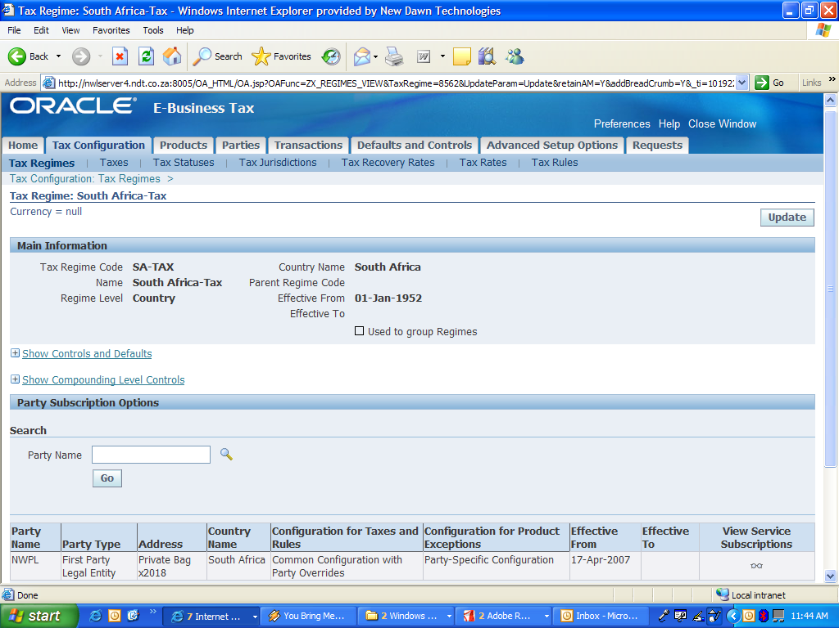

This is the Tax (Exempt Vat) that I want to use for now, testing purposes.

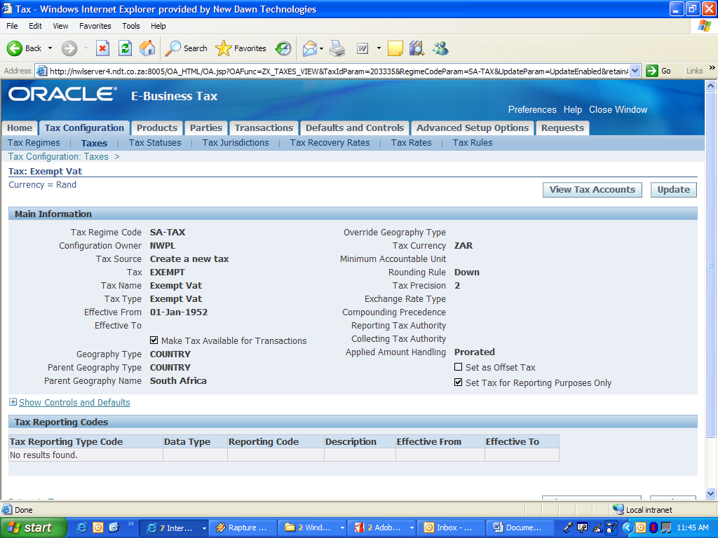

This is the Tax Status for the Tax I want use.

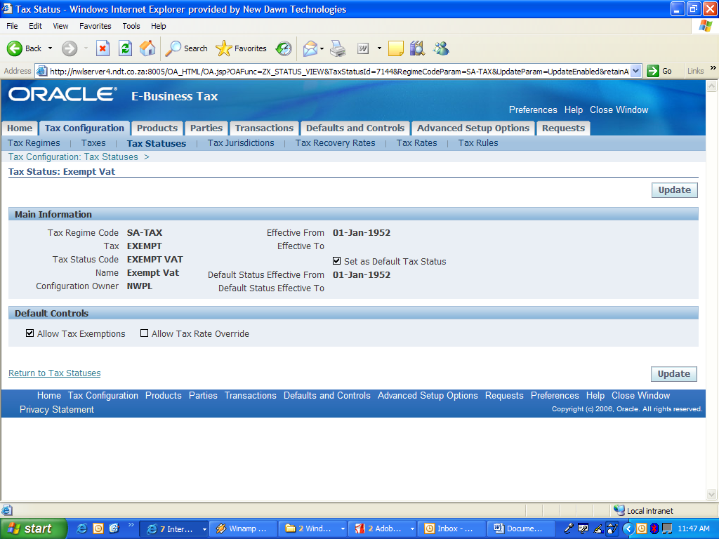

This is the tax jurisdiction I have created for that tax I want to use.
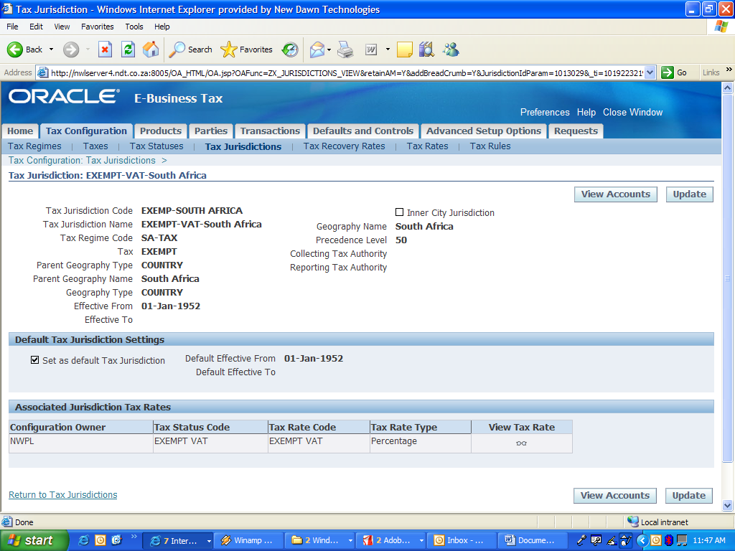

These are the Tax Rate I have created for the tax I want to use.
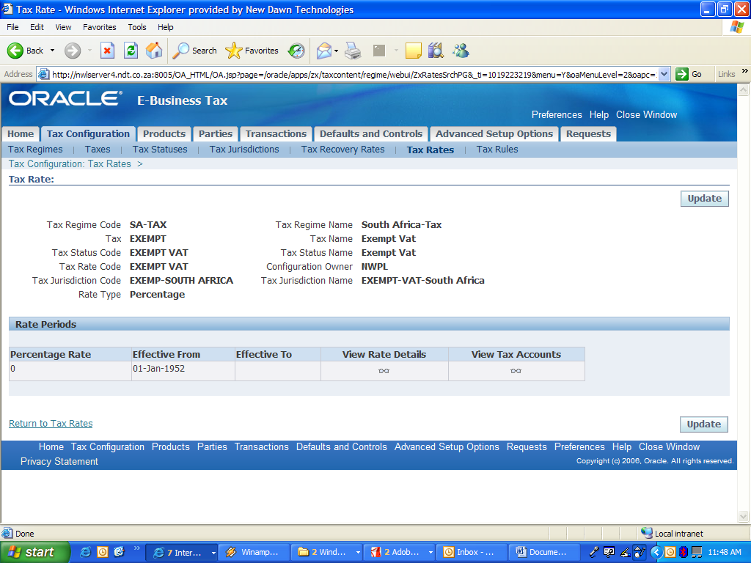

These are the Tax Rules.
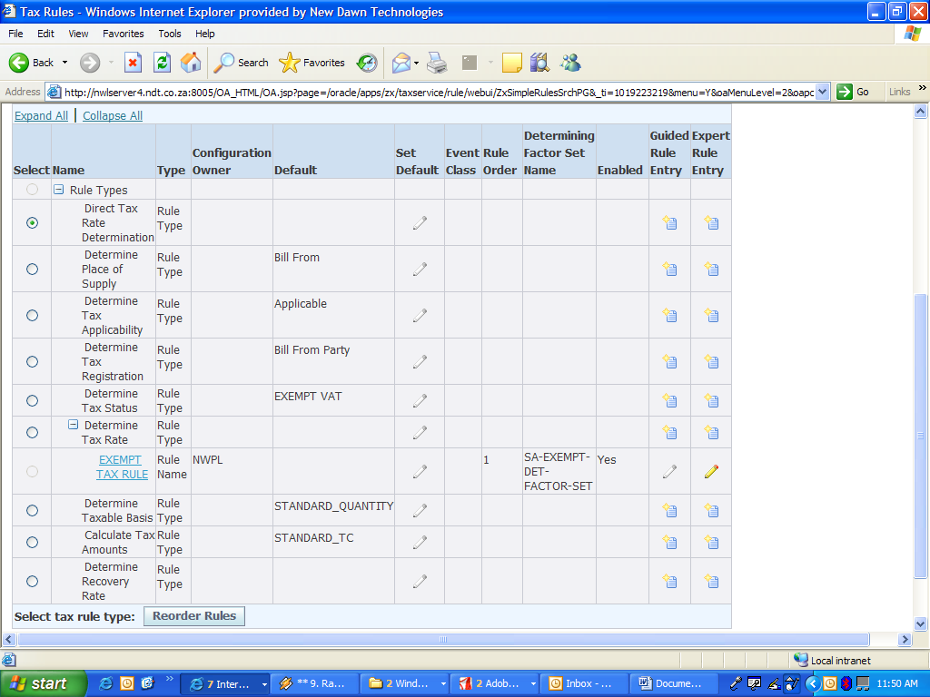

This is for the Determine Tax Rate 